Project Development Phase
Performance Test
Date | 1 October 2026
Team ID | PNT2022TMIDxxxxxx
Project Name | Import Data using Transform Maps (Spreadsheet) - ServiceNow
Maximum Marks

Model Performance Testing:
Project team shall fill the following information in model performance testing template.
S.No. | Parameter | Screenshot / Values
1. | Data Rendered | Employee spreadsheet data (Employee ID, Employee Name, Email, Department, Location) loaded into the custom Employee Test table (u_employee_test) in ServiceNow.  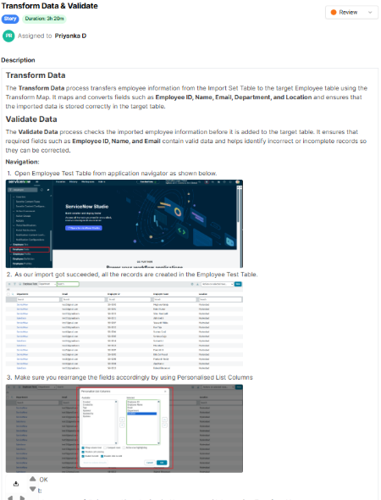
2. | Data Preprocessing | Data first goes to the Employee Import staging table (u_employee_import), is mapped to Employee Test by the Sample Spreadsheet Import transform map, and is validated for Employee ID, Name and Email.  Coalesce on Employee ID prevents duplicates: a first re-import gave 2 inserted and 2 updated; a second gave 0 inserted, 0 updated, 4 ignored.  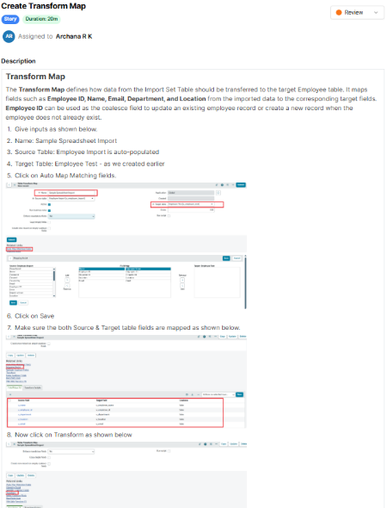  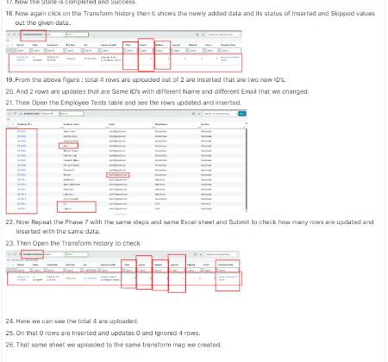
3. | Utilization of Filters | Not applicable. No filters appear in the project screenshots; Personalised List Columns were used to arrange the fields in the Employee Test list.
4. | Calculation fields Used | Count aggregation grouped by the Department field in the Employees by Department report.
5. | Dashboard design | No of Visualizations / Graphs - 1 (pie chart, Employees by Department)  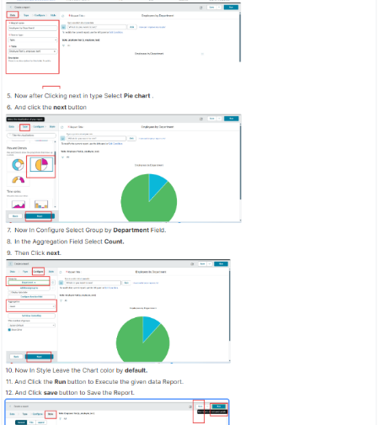
6. | Story Design | Not applicable. The project is organised as 4 milestones: spreadsheet and table creation, import set and transform map, transform / validate / coalesce, and reports and dashboards.

